Tourbillon Skelet Red Gold - Bon Jovi:
It’s his life
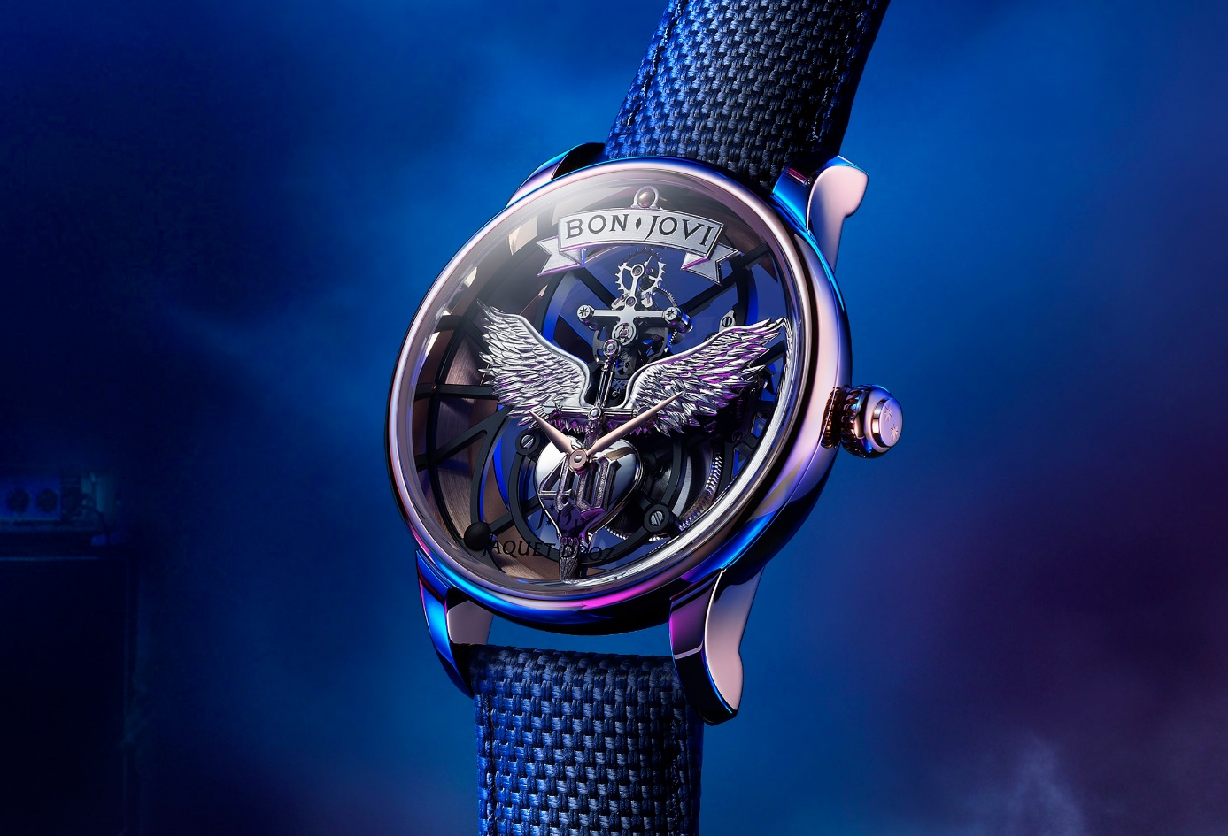
What more can you want when you've already reached the heights of fame? In a career spanning 40 years, the band Bon Jovi has sold over 130 million albums and its frontman, Jon Bon Jovi, has spanned the decades as a rock star with mass-market appeal, a shrewd entrepreneur and a committed campaigner renowned for his philanthropy. Now at this mature stage of his life, his accomplishments are driving him on to new horizons. Among these, his desire for a watch that reflects his personality: exacting, disruptive, unique. The path between his native New Jersey and La Chaux-de-Fonds opened up before him, and could only stop at Jaquet Droz...

His fans number in the hundreds of millions, but none of them will have this unique watch. The Tourbillon Skelet Red Gold - Bon Jovi is in keeping with Jaquet Droz's "Philosophy of the Unique": a piece created by, for and with Jon Bon Jovi, a one-of-a-kind watch which will be owned by him alone - although his fans will be able to draw inspiration from it to create their own.
Developed in close collaboration with the rock star, this timepiece will be on his wrist for the world tour to celebrate his band's 40th anniversary. Featuring a 41-mm red gold case, it brings together the DNA of Bon Jovi and the essence of Jaquet Droz's "Disruptive Legacy".
It is a timepiece like no other. Its airy design is devoid of a dial. In a taut, edgy, highly contemporary architecture, its movement is secured to the case by a complex geometry of linear bridges treated with black PVD. At 12 o'clock, the tourbillon seems to float in mid-air. It is set against a large, hand-crafted white gold applique: the logo features two wings spread out on either side of a dagger, plunged into a heart engraved with the number "40" to mark the group's special anniversary. The two hour and minute hands are set here, literally 'at the heart' of the watch, creating a rich symbolism – between the soul and time, the heart and mind – which was particularly important to the artist. Entirely engraved and polished by hand, this logo is an original design that will be used throughout the band's anniversary tour.
At the heart of this composition, what appears to be one assembly actually comprises many individual parts. On one side there are the wings and the dagger, then the heart, and finally the '4' and the '0'. By separating the components, Jaquet Droz was able to given them a specific finish. Satin-brushed, polished and grained surfaces intertwine fluidly and naturally, beneath the unfurled wings which are hand-engraved from a solid gold block. The applique that tops it all bears the artist's name. The simple title "Bon Jovi" was actually particularly tricky to create: The text is in the group's own font and also had to be created by hand to reproduce the height, depth, spacing and angles.
Jon Bon Jovi personally oversaw the creation of this self-winding timepiece with its 8-day power reserve. His philosophy in life is summed up perfectly in one of his greatest songs: "It’s My Life".
“Create your own. As unique as you are”

Breaking news: Unique timepiece hand-delivered to Palm Beach
Just a few days ago, CEO of Jaquet Droz Alain Delamuraz met Jon Bon Jovi near his home in Palm Beach where he presented this unique piece to him in person. Visibly touched by this gesture, the artist devoted a large part of his day to talking with the Jaquet Droz team in depth about the brand's vision of time, watchmaking and creativity, enjoying many photo opportunities throughout. The artist met the Jaquet Droz team on the roof top of a hotel just a stone's throw from his home which, once again, embodies Jaquet Droz's disruptive approach – freed from the commercial model of boutiques and where each customer is the object of unique and dedicated attention.

